Lesson Plan
Square Foot Garden
Teacher, Amy Spies
Grade 4, Cypress Creek ES
Volusia County, FL

Objective:
Students will create and explain a representation to show multiplication of a fraction by a whole number. Students will critique the strategy of others.
Summary
Presented with a contextual situation students are asked to create a representation to show 4 x 2/3. After sharing within a small group setting the group will record one solution on chart paper and justify the solution to the whole group. Students will then critique the strategies noting any misconceptions.
Context: What happened before this lesson? What will happen after? What knowledge and skill do students need before this lesson?
Students have extensive practice working with unit fractions, finding equivalent fractions, decomposing fractions, and comparing fractions. They have modeled these with fraction bars, fraction circles, number lines, and bar models. Students have worked with multiplication with whole numbers first by modeling with arrays, area model, partial product and then the standard algorithm. Students have also had extensive practice working within small groups, analyzing others’ strategies, and practiced critiquing and receiving feedback from one another. Following practice with other problems using whole number x fractions less than one students will then attempt situations using whole number x fractions greater than one.
Materials: Resources used when planning this lesson
Common Core State Standards
Progression Document 3-5 Numbers and Operations – Fractions
Illustrative Mathematics website with tasks
Thinking Mathematics research and trainer manuals
Common Core Flip Book, grade 4
“Righting the Wrongs” video of Chinese fractions lesson
PARCC Mathematics Evidence Tables
Student notebooks with previous work to evaluate levels of understanding

Math Practice Standards: This lesson addresses the following Common Core practice standards.
CCSS.Math.Practice.MP2 Reason abstractly and quantitatively.
CCSS.Math.Practice.MP3 Construct viable arguments and critique the reasoning of others.
MP2: Students will identify the quantities within the problem as a fraction and a whole number and recognize that the fractional amount is being repeated. Using various strategies students will have to manipulate the numbers to determine the total quantity needed and create a logical representation of the problem. Students will then relate that amount back to the context of the situation.
MP3: Students while in small groups will: analyze the problem and use stated mathematical assumptions, definitions, and established results in constructing an argument; justify conclusions with mathematical ideas; listen to the arguments of others and ask useful questions to determine if an argument makes sense.; ask clarifying questions or suggest ideas to improve/revise the argument; compare two arguments and determine correct or flawed logic to determine the strategy to share with the whole group.
Common Core Content Standard addressed:
4.NF.4.b,c
Apply and extend previous understandings of multiplication to multiply a fraction by a whole number.

Differentiation: How will this lesson be differentiated for all students (if at all)?
All students will be given the same initial task. Specific prompts will guide those struggling to start like, “What do we know about the situation? Can you draw what is happening? What have we with done with fractions that might help?”
For students who quickly determine a solution possible extension questions include, “Is there another way to prove that is correct? What other model would justify your solution? Why isn’t it 8/12?”

Assessment:
The teacher will circulate during independent work time noting correct or incorrect strategies and solutions. During small group discussion the teacher will listen for explanations with solid mathematical reasoning or those with misconceptions or errors. Those will be highlighted and discussed during the whole group review. During whole group discussion hand signals of thumbs up or down will be used to track students’ level of understanding. At the conclusion students will complete a summary statement to be used to guide further instruction.

Lesson Flow:
Give a label to students to add to their math notebooks with the following problem, “Mrs. Russell wants us to have ribbons on each corner of our garden identifying the various crops. She determined 2/3 of a yard was the perfect length for each ribbon. Since ribbon is sold by the yard, how much should be purchased for all four corners? Create a representation to justify your thinking.”
Allow students to first work through the problem individually. Monitor responses noting misconceptions and correct strategies. Prompts may include:
What do we know about the situation?
Can a drawing help you see what is happening?
Is there another way to prove your answer is correct?
What does that amount tell you?
Does this look like any problems we have done before? Why or why not?
How did you determine that amount?
What do the numbers used in the problem represent?
What does the 4 tell us? The 2/3?
How is the number of ribbons related to 2/3 yards?
What operations might we use to find a solution?
How did you decide in this task that you needed to use...?
Could we have used another operation or property to solve this task? Why or why not?
Once students have had time to record at least one strategy, have each person explain their strategy to their group. Other group members should ask questions for clarification. Group members should then decide on a strategy to record on chart paper to share with the whole group.
Monitor the groups while they are recording on chart paper to determine the sequence of reporting out. Strategies should be shared staring with the most basic, simplistic, or misconception and ending with the most complex or abstract.
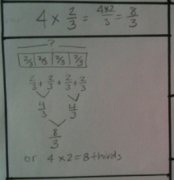
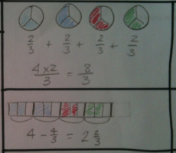

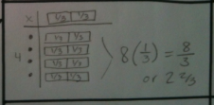
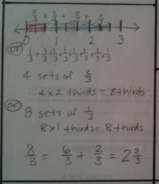

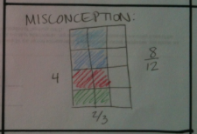

Facilitate whole group discussion of solution strategies. Hang charts on board in order of the progression to be shared. Have one member from each group explain the solution. During the explanations highlight examples of mathematical reasoning and have students critique any misconceptions and explain the error. Prompts may include:
You said what you did, now tell us why you did that.
What mathematical evidence would support your solution?
How can we be sure that...?
How could you prove that...?
Will it still work if...?
What were you considering when...?
How did you decide to try that strategy?
How did you test whether your approach worked?
How did you decide what the problem was asking you to find? (What was unknown?)
Did you try a method that did not work? Why didn’t it work? Would it ever work? Why or why not?
What is the same and what is different about...?
If no solution shows (4x2)/(4x3) show worked out incorrect strategy and ask, “A student last year did this. Does this work? Why or why not?”
Summarize the strategies presented, emphasizing the following points:
- Multiplication can be used to calculate repeated addition quantities with fractions like it can for whole numbers.
- Various models can prove this works.
- When multiplying a fraction by a whole number the denominator is not multiplied as the size of the fraction pieces does not change.
Ask students to complete a summary statement for the following, “You have seen various ways to multiply a fraction by a whole number. Decide on one strategy and use it to explain how to find 3 x 2/5.

Post-lesson note from Mrs. Spies:
An adjustment was made in the lesson since no student groups represented the situation as multiplication of a fraction by a whole number. I then re-grouped the students and had them discuss whether or not worked out solutions were correct. Those cards are attached in the file “SpiesLesson1PossibleSolutions.doc”

Student samples from their math notebooks with descriptions are included in the file “TeachChannelStudentSample.doc”

An alternate summary activity that can be used is provided in the file “SpiesLesson1Summary.doc”

